Did you ever want to know How 2…. Make Whisky and Gin?

Well now is your chance.
Join us at the Fleurieu Distillery right here in Goolwa.
Gareth Andrews will take us through the finer points and give us a look behind what goes into making award winning spirits.
Gareth began the Steam Exchange Brewery in 2004 and was one of only three craft breweries in South Australia at the time.
The success of the business has allowed him to eventually become a distillery, which had been a long-term goal. The businesses focus is now 90 per cent whisky, 5 per cent gin and five per cent beer.
When: Wednesday 4th May at 4pm
Where: Fleurieu Distillery on the Wharf
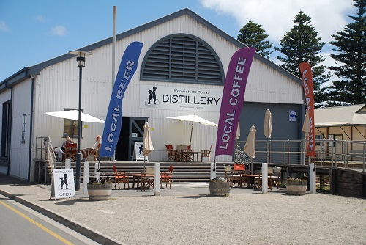
Following a tour and talk we will have an opportunity to try some of Gareth’s products at a discounted price.
This is a free event. Numbers are definitely limited.
Please book by email to Debbie Smith - famsmith@internode.on.net

